Project Design Phase-II
Technology Stack (Architecture & Stack)

Date: | 12 Feb 2026
Team ID: | LTVIP2026TMIDS35994
Project Name: | Househunt: finding your perfect rental home
Maximum Marks: | 4 Marks

Technical Architecture
The architecture for the Rent Ease project follows a client–server model using the MERN stack. The system provides a web-based platform where renters, property owners, and administrators interact through a React.js frontend. User requests are processed by a Node.js and Express.js backend, while MongoDB is used for secure and scalable data storage. JWT-based authentication ensures secure access and role-based authorization across the system.
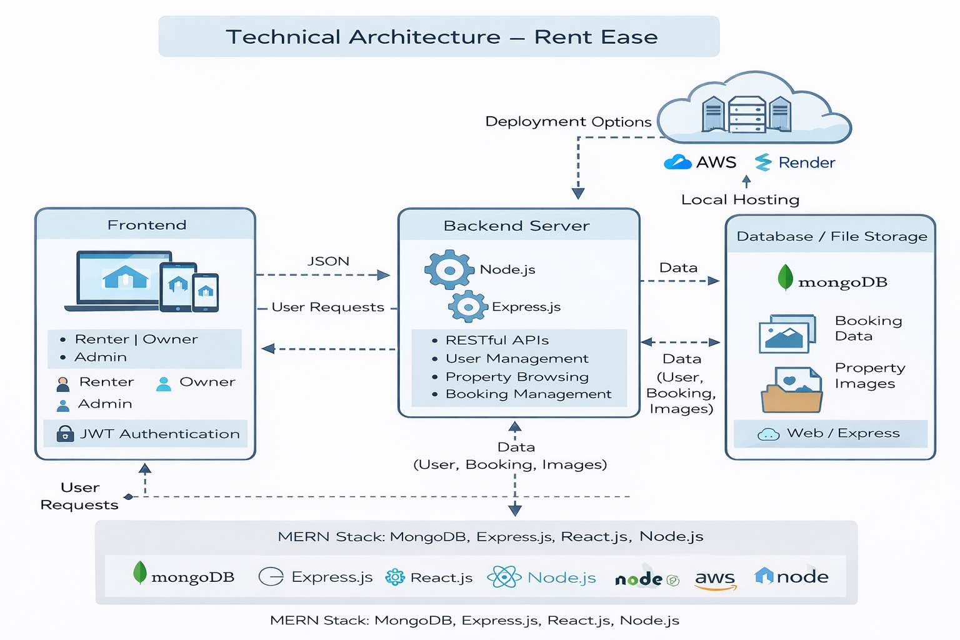
Table-1: Components & Technologies
Component | Description | Technology
User Interface | Web interface for renters, owners, and admin | React.js, HTML, CSS, Bootstrap
Application Logic-1 | Handles API requests and business logic | Node.js, Express.js
Application Logic-2 | Authentication and authorization | JSON Web Tokens (JWT)
Database | Stores user, property, and booking data | MongoDB
File Storage | Stores uploaded property images | Local Storage / Cloud Storage
Backend Server | RESTful API services | Node.js, Express.js
Infrastructure | Local or cloud-based deployment | Localhost / Render / AWS

Table-2: Application Characteristics
Characteristics | Description | Technology
Open-Source Frameworks | Used for frontend and backend development | React.js, Node.js, Express.js
Security Implementations | Secure login and role-based access | JWT, bcrypt
Scalable Architecture | Modular MERN stack enables future expansion | REST APIs, MongoDB
Availability | Accessible via web browser anytime | Web Application
Performance | Fast response for search, booking, and updates | Optimized REST APIs

References
- https://react.dev/
- https://nodejs.org/
- https://expressjs.com/
- https://www.mongodb.com/
- https://jwt.io/

